To Backup MySQL

Start/All Program/MySQL/MySQL Administratior

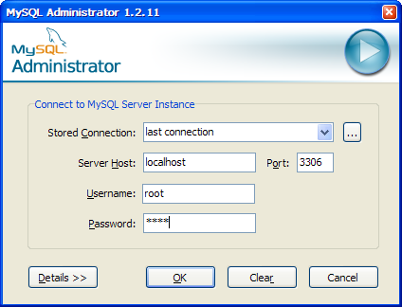

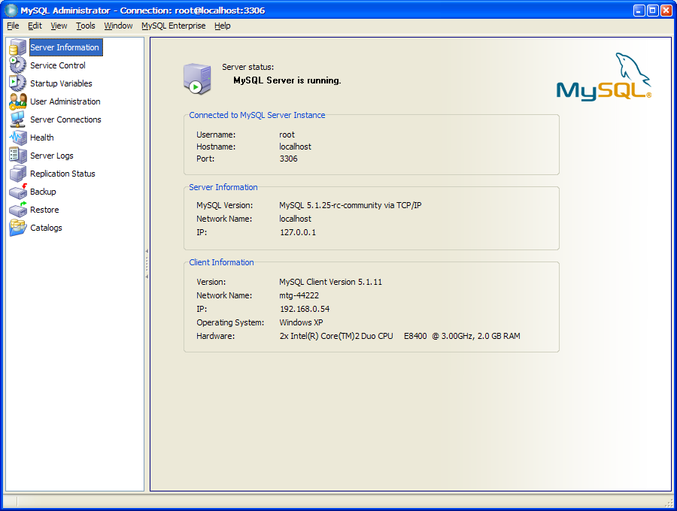

From MySQL Administrator,

Choose Backup

Click New Project

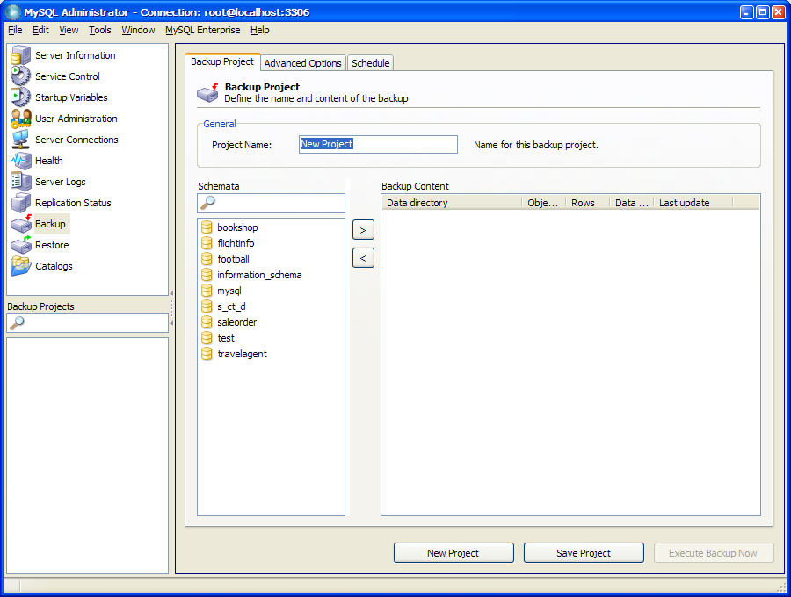

* Then choose database you want to backup
* Click

>

* Click Execute Backup Now
* Save to the backup file you want to store
* Then you can see the backup was finished successfully.

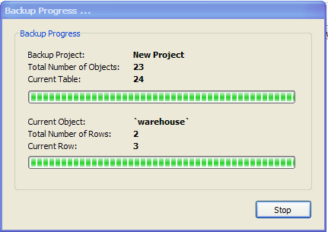

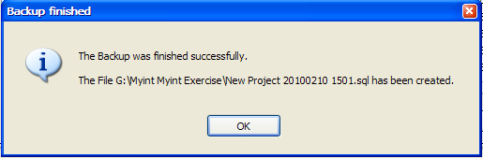

To Restore MySQL

Start/All Program/MySQL/MySQL Administratior

Click Restore

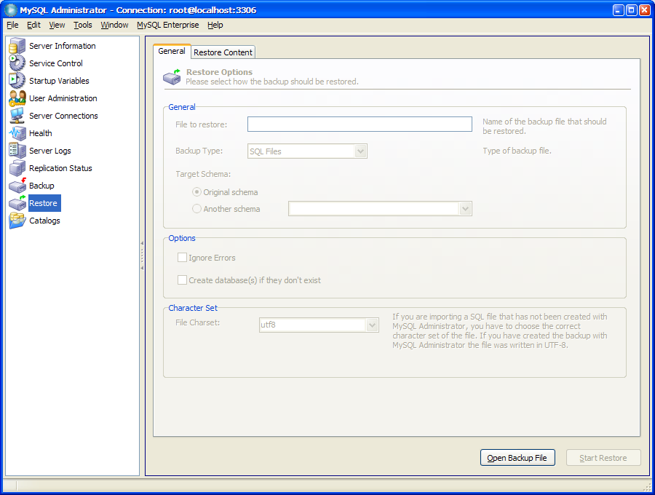

Then, Click the Open Backup File , Choose the file you want to backup, then Click Start Restore.

